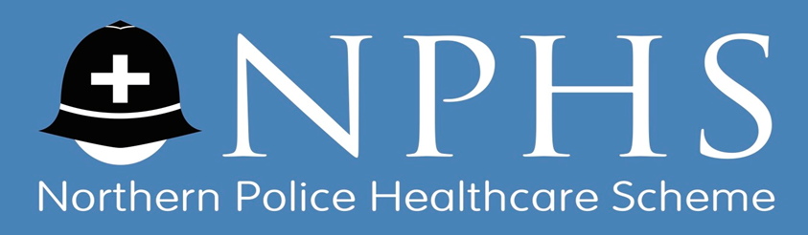

Dear Healthcare Scheme Member

Thank you for continuing to subscribe to The Northern Police Healthcare Scheme we really value your loyalty.

As a token of our appreciation, if you recommend a friend/colleague (who must be a serving police officer or police staff member) who then joins the Scheme, you will receive £25.

You can refer as many friends/colleagues as you like, so each time a new member is referred by you, that’s another £25 in your pocket.

Once your nominee joins the Scheme and makes 3 payments, we will email you requesting your bank details to make the appropriate incentive payment directly into your account. It’s that simple!

Please complete the attached form.

We look forward to hearing from you.

On behalf of the Trustees of the Northern Police Healthcare Scheme

11-14 Apex Business Village | Annitsford | Cramlington | Northumberland | NE23 7BF
Tel: 0191 437 3000 | Fax: 0191 250 2961 | Email: Healthcare@npf.polfed.org|
Website: www.norpolfed.org.uk VAT Reg No. 993179764

REFER A FRIEND & RECEIVE £25

Please provide the following details and return this form to the above address or via email to Healthcare@npf.polfed.org

Your Name:

Your Payroll/Pension Number:

Your Contact Number:

Your Email Address:

Your Friend’s Name:

Your Friends Force Number:

Your Friend’s Email Address:

